**CSCI 1152, Summer 2020  
Lab Assignment 3**

# Objectives

1. Learn how to use and process arrays.
2. Learn how to write methods to operate on arrays.

# Description

Write a Java program that will process rainfall data from 1970 to 1990. The program will determine the average rainfall, the year with the smallest amount of rain fall and the year with the largest amount of rainfall. The rainfall data is shown in the chart below:

|  |  |
| --- | --- |
| **Year** | **Rainfall (inches)** |
| 1970 | 0.2744447 |
| 1971 | 0.036378264 |
| 1972 | 1.4680095 |
| 1973 | 2.8227994 |
| 1974 | 2.2719026 |
| 1975 | 2.0574791 |
| 1976 | 2.6848125 |
| 1977 | 0.56718653 |
| 1978 | 0.9973374 |
| 1979 | 0.39861685 |
| 1980 | 0.8117836 |
| 1981 | 1.2329354 |
| 1982 | 2.4103663 |
| 1983 | 2.4921546 |
| 1984 | 2.2694077 |
| 1985 | 0.78657675 |
| 1986 | 0.105816364 |
| 1987 | 0.8013573 |
| 1988 | 0.6838444 |
| 1989 | 0.20090479 |
| 1990 | 2.089554 |

To complete this program you must do the following:

1. In the main method declare and initialize a year integer array with the data from column 1.
2. In the main method declare and initialize a rainfall float array with the data from column 2.
3. Write a method that calculates the average rainfall for the rainfall data. See requirements below.
4. Write a method that determines the year that had the largest rainfall. See requirements below.
5. Write a method that determines the year that had the smallest rainfall. See requirements below.

# Requirements

1. The class name is required to be Lab3_<your email id>
   1. For example, my class would be:

public class Lab3_mgonzales183 {

}

* 1. Your class must hava a Javadoc comment as follows:

1. Your class must hava a Javadoc comment as follows:

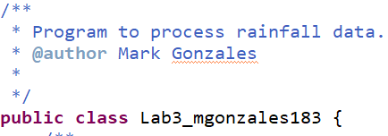

1. The main method must have arrays that are declared and initialized with the table data. One array will be called years and declared as an integer array, initialized with column 1 data. The second array will be called rainfall and declared as a float array, initialized with column 2 data.
2. The main method will call the other methods to do the calculations.
3. The calculateAverage method:
   1. Name: calculateAverage
   2. Return Type: float that represents the average rainfall for the data in column 2.
   3. Parameters:
      1. Parameter one is an array of floats that represents the rainfall data.
   4. Your calculateAverage method must have a Javadoc comment as follows:

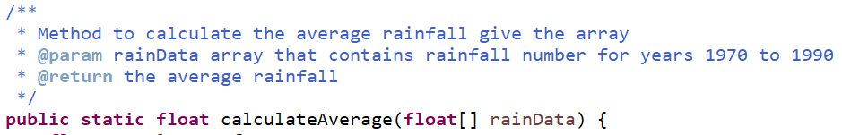

1. The findLargestRainfallYear:
   1. Name: findLargestRainfallYear
   2. Return Type: integer that represents the year that had the largest rainfall.
   3. Parameters:
      1. Parameter one is an array of integers that represents the year data.
      2. Parameter two is an array of floats that represents the rainfall data.
   4. Your findLargestRainfallYear method must have a Javadoc comment as follows:

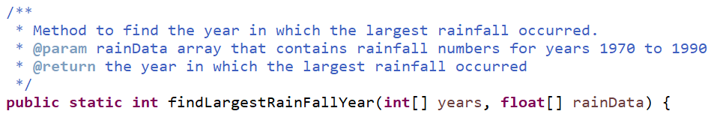

1. The findSmallestRainfallYear:
   1. Name: findSmallestRainfallYear
   2. Return Type: integer that represents the year that had the smallest rainfall.
   3. Parameters:
      1. Parameter one is an array of integers that represents the year data.
      2. Parameter two is an array of floats that represents the rainfall data.
   4. Your findSmallestRainfallYear method must have a Javadoc comment as follows:

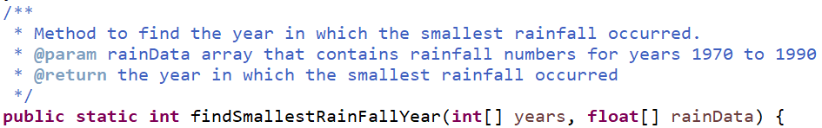

1. The code output must match the sample output.

# Sample Output

The Average Rain Fall: 1.31 🡨Note: only two decimal points displayed.

The Largest Rain Fall Year: 1973

The Smallest Rain Fall Year: 1971

# Testing

I will test your program as follows:

javac Lab3_<your email id>.java

java Lab3_<your email id>

# Steps

## calculateAverageMethod

1. Write a for loop to sum up the rainfall data and thus calculates total rainfall.
2. Calculate the average rainfall.
3. Return the average rainfall.

# findLargestRainFallYear

1. Write a for loop to find the index at which the largest rainfall occurs.
   1. You will need a variable to keep track of the maximum rainfall value
   2. You will need a variable to keep track of the index at which the maximum rainfall occurs.
2. Return the year using the index found with the for loop

# findSmallestRainFallYear

1. Write a for loop to find the index at which the smallest rainfall occurs.
   1. You will need a variable to keep track of the minimum rainfall value
   2. You will need a variable to keep track of the index at which the minimum rainfall occurs.
2. Return the year using the index found with the for loop

## Main Method

1. Initialize a year integer array with the data from column 1.
2. Initialize a rainfall float array with the data from column 2.
3. Call the calculateAverage method.
4. Print out the result from the calculateAverage method according to the sample output.
5. Call the findLargestRainFallYear method.
6. Print out the result from the findLargestRainFallyear method according to the sample output.
7. Call the findSmallestRainFallYear method.
8. Print out the result from the findSmallestRainFallyear method according to the sample output.